IoT Internship Report
Tasks 1, 2 & 4 — Complete Documentation

Tools Used: Arduino IDE | Proteus 8 Professional | LM35 Sensor
Components: Arduino UNO | 16x2 LCD | LED | Buzzer

Name: Muhammad Faizan

Task 1: Introduction to IoT & Device Communication

1.1 What is IoT?
IoT stands for Internet of Things. It refers to a network of physical devices — like sensors, machines, vehicles, and home appliances — that are connected to the internet and can collect, send, and receive data automatically, without needing a human to press buttons or give commands.
Think of a smart refrigerator that notices you are running low on milk and sends you a notification on your phone. That is IoT in action. The fridge (a physical device) is connected to the internet and communicates with your phone (another device) — all on its own.
IoT is making our homes smarter, our cities more efficient, our hospitals safer, and our factories more productive. It is one of the fastest-growing technologies in the world today.

1.2 IoT Architecture (4-Layer Model)
IoT systems are usually described using a four-layer architecture. Each layer has a specific job:
Layer | Name | What it Does | Example
Layer 1 | Perception Layer | Collects data from the physical world using sensors and actuators | LM35 temperature sensor reading room temperature
Layer 2 | Network Layer | Transfers the collected data to other devices or the cloud | Wi-Fi module sending temperature data to a server
Layer 3 | Processing Layer | Analyzes and processes the received data | Cloud server deciding if the temperature is too high
Layer 4 | Application Layer | Delivers the result to the end user or triggers an action | Sending an alert to your phone or turning on a fan

In our project, the LM35 sensor acts as Layer 1. The Arduino processes data at Layer 3. The LCD display and buzzer are the output at Layer 4.

1.3 Device Communication in IoT
IoT devices talk to each other using different communication protocols. A protocol is just a set of rules that devices follow so they understand each other — like a shared language.
- MQTT (Message Queuing Telemetry Transport): Lightweight protocol used in low-power IoT devices. Works on a publish/subscribe model. Very popular for smart home systems.
- HTTP/HTTPS: The same protocol your web browser uses. IoT devices can send data to web servers using HTTP requests.
- Zigbee: A short-range, low-power wireless protocol. Used in smart bulbs, door sensors, and other home automation devices.
- Wi-Fi: Standard internet connection. Most commonly used when power is available and data speed matters.
- Bluetooth/BLE: Short-range communication, commonly used for wearables and medical devices.

1.4 Real-World IoT Examples
Example 1: Smart Home Thermostat
A temperature sensor inside a smart thermostat monitors room temperature continuously. When the temperature drops below a set point, it automatically turns on the heater. You can also control it remotely from your smartphone, no matter where you are. This saves energy and keeps your home comfortable.
Example 2: IoT in Healthcare
Wearable health monitors like smartwatches track your heart rate, blood oxygen level, and body temperature. This data is sent in real-time to a hospital database. Doctors can see if a patient's condition is changing without the patient needing to be physically present in the hospital — especially helpful for elderly patients at home.
Example 3: Smart Agriculture
Farmers use soil moisture sensors placed in their fields. These sensors send data to a central system that automatically turns on irrigation when the soil is too dry and turns it off when moisture reaches the right level. This saves water, reduces cost, and improves crop yield.

1.5 Data Flow in an IoT System
Data in an IoT system flows in a clear, step-by-step path:
- Sensor detects something (temperature, humidity, light, motion)
- Microcontroller (like Arduino) reads the sensor value
- Data is processed — calculations done, decisions made
- Data is displayed locally (LCD) or sent to the cloud via Wi-Fi/MQTT
- Cloud server stores and analyzes the data
- User gets notified via an app, or an action is triggered automatically
In our lab simulation, steps 1 through 4 happen inside Proteus using Arduino UNO. The LCD acts as the local display, and the LED/buzzer act as the automated action.

Task 2: Sensor Data Simulation — Temperature Monitoring

2.1 Objective
In this task, we simulate an IoT temperature monitoring system using an LM35 temperature sensor and an Arduino UNO. The temperature reading is displayed live on a 16x2 LCD screen, just like you would see in a real IoT monitoring device.

2.2 Components Required
Component | Proteus Library Name | Quantity
Arduino UNO | ARDUINO UNO R3 | 1
LM35 Temperature Sensor | LM35 | 1
16x2 LCD Display | LM016L | 1
10kΩ Potentiometer (LCD contrast) | POT-HG | 1
Connecting Wires | — | As needed
Power Supply (5V) | POWER | 1

2.3 Circuit Wiring — Pin by Pin
LCD (LM016L) to Arduino UNO
LCD Pin No. | LCD Label | Connect To
Pin 1 | VSS (Ground) | Arduino GND
Pin 2 | VDD (Power) | Arduino 5V
Pin 3 | V0 (Contrast) | Potentiometer Middle Pin
Pin 4 | RS | Arduino Digital Pin 12
Pin 5 | RW (Read/Write) | Arduino GND (always write mode)
Pin 6 | EN (Enable) | Arduino Digital Pin 11
Pin 11 | D4 | Arduino Digital Pin 5
Pin 12 | D5 | Arduino Digital Pin 4
Pin 13 | D6 | Arduino Digital Pin 3
Pin 14 | D7 | Arduino Digital Pin 2
Pin 15 | A / LED+ | Arduino 5V
Pin 16 | K / LED- | Arduino GND

LM35 Sensor to Arduino UNO
LM35 Pin | Description | Connect To
Left Pin (+VS) | Power Supply | Arduino 5V
Middle Pin (VOUT) | Analog Output | Arduino A0
Right Pin (GND) | Ground | Arduino GND

Potentiometer (Contrast Control)
Pot Pin | Connect To
Left Terminal | Arduino 5V
Middle (Wiper) | LCD Pin 3 (V0)
Right Terminal | Arduino GND

2.4 How LM35 Works
The LM35 is a precision temperature sensor. It produces an analog voltage that is directly proportional to temperature. For every 1 degree Celsius increase in temperature, the output voltage increases by exactly 10 millivolts.
The Arduino reads this voltage using its built-in Analog-to-Digital Converter (ADC), which converts the voltage (0 to 5V) into a number between 0 and 1023.
We convert this number to a real temperature using this formula:
Temperature (°C) = (ADC Value × 5.0 / 1023.0) × 100
For example: If ADC reads 512 → Temperature = (512 × 5.0 / 1023.0) × 100 = 25.02°C

2.5 Arduino Code
Copy this code exactly into Arduino IDE. It includes the LCD library and temperature reading logic:
#include <LiquidCrystal.h>

// LCD: RS=12, EN=11, D4=5, D5=4, D6=3, D7=2
LiquidCrystal lcd(12, 11, 5, 4, 3, 2);
const int lm35Pin = A0;
float temperature = 0.0;

void setup() {
lcd.begin(16, 2);
Serial.begin(9600);
lcd.print("IoT Temp Monitor");
delay(2000);
lcd.clear();
}

void loop() {
int rawValue = analogRead(lm35Pin);
temperature = (rawValue * 5.0 / 1023.0) * 100.0;

lcd.setCursor(0, 0);
lcd.print("Temperature: ");
lcd.setCursor(0, 1);
lcd.print("Temp: ");
lcd.print(temperature, 1);
lcd.print(" C ");

Serial.print("Temp: ");
Serial.println(temperature);
delay(1000);
}

2.6 Proteus Simulation Steps
- Open Proteus 8. Go to File → New Project. Set the name to 'IoT_Temperature_Monitor'.
- Click the Component icon (P button). Search for 'ARDUINO UNO R3' — add it to workspace.
- Search for 'LM35', 'LM016L', and 'POT-HG' — add each to workspace.
- Wire all connections as described in Section 2.3 above.
- Open Arduino IDE. Paste the code from Section 2.5. Go to Sketch → Export Compiled Binary.
- In Proteus, right-click Arduino → Edit Component → Browse for the .hex file. Click OK.
- Press Play (F5) in Proteus to start simulation.
- Click on the LM35 component and drag the voltage slider to simulate different temperatures.
- Watch the LCD display update with temperature readings.

2.7 Expected Output
LM35 Voltage Set | ADC Value (approx) | Temperature Displayed on LCD
0.25V | 51 | Temp: 25.1 C
0.30V | 61 | Temp: 30.0 C
0.37V | 75 | Temp: 37.0 C
0.40V | 82 | Temp: 40.0 C

2.8 Screenshots to Capture
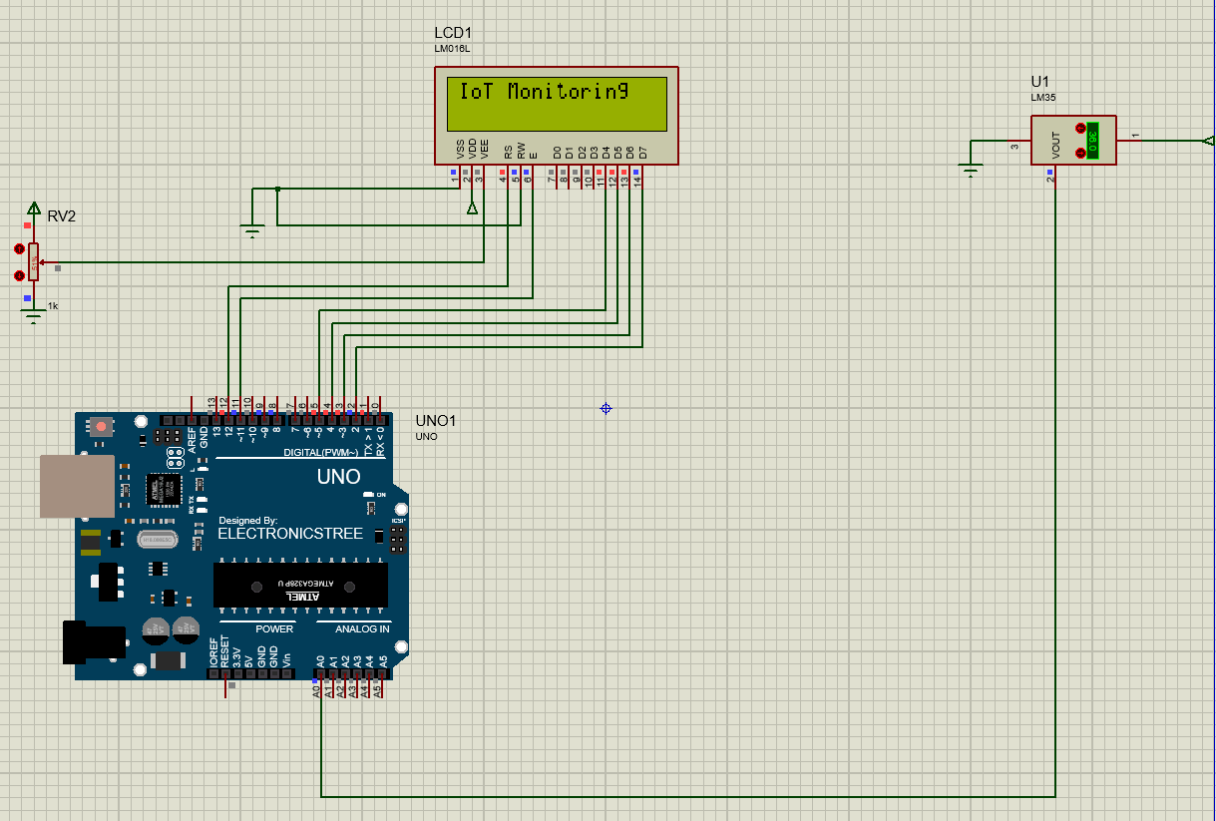

Figure 1 Temperature Monitoring Circuit
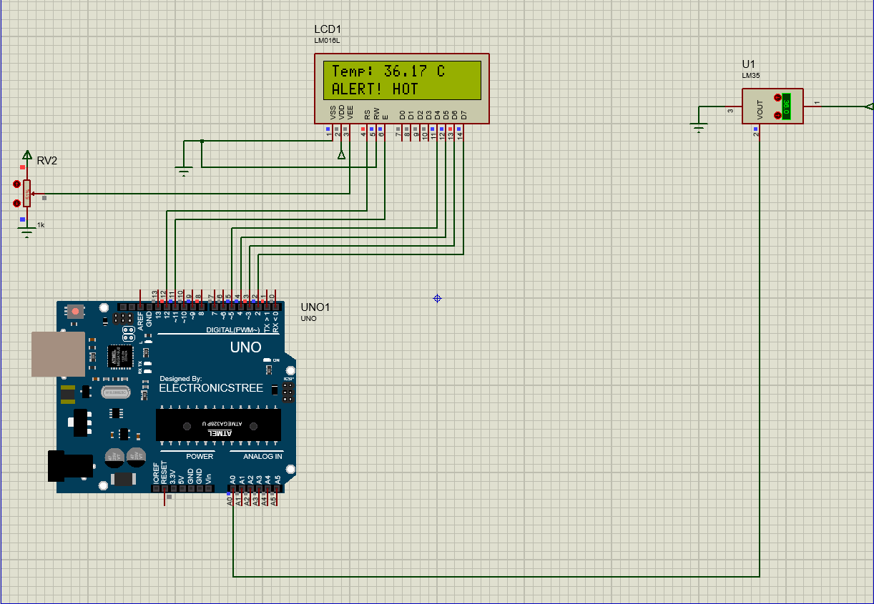
Figure 2 LCD Displaying Temperature

Task 4: IoT Automation Logic — LED & Buzzer Alert System

4.1 Objective
This task builds on Task 2 by adding automation. We define a rule: if the temperature goes above 35 degrees Celsius, the system automatically turns on an LED and a buzzer to warn the user. If the temperature is normal (35°C or below), they remain off. This is a basic example of IoT-based automation.

4.2 Additional Components (Reuse Task 2 Circuit)
You do NOT need to rebuild the circuit from scratch. Keep everything from Task 2 and just add these two components:
New Component | Proteus Name | Quantity
Red LED | LED-RED | 1
Active Buzzer | BUZZER | 1
220Ω Resistor (for LED) | RES | 1

4.3 Additional Wiring
Component | Connection
LED Anode (+) | 220Ω Resistor → Arduino Digital Pin 8
LED Cathode (−) | Arduino GND
Buzzer (+) | Arduino Digital Pin 9
Buzzer (−) | Arduino GND

4.4 Automation Logic Explained
The core logic is simple. We set a threshold value of 35.0 degrees Celsius in the code. Every second, the Arduino checks the current temperature. If it is above the threshold, it turns on the LED and buzzer. If not, it turns them off.
IF (temperature > 35.0°C):
LED → HIGH (ON)
Buzzer → HIGH (ON)
LCD Row 2 → "** ALERT! HOT **"
ELSE:
LED → LOW (OFF)
Buzzer → LOW (OFF)
LCD Row 2 → "Status: Normal"

4.5 Arduino Code (Complete)
#include <LiquidCrystal.h>

LiquidCrystal lcd(12, 11, 5, 4, 3, 2);
const int lm35Pin = A0;
const int ledPin = 8;
const int buzzerPin = 9;
const float THRESHOLD = 35.0;
float temperature = 0.0;

void setup() {
pinMode(ledPin, OUTPUT);
pinMode(buzzerPin, OUTPUT);
digitalWrite(ledPin, LOW);
digitalWrite(buzzerPin, LOW);
lcd.begin(16, 2);
Serial.begin(9600);
lcd.print("IoT Automation");
delay(2000);
lcd.clear();
}

void loop() {
int rawValue = analogRead(lm35Pin);
temperature = (rawValue * 5.0 / 1023.0) * 100.0;

lcd.setCursor(0, 0);
lcd.print("Temp: ");
lcd.print(temperature, 1);
lcd.print(" C ");

if (temperature > THRESHOLD) {
digitalWrite(ledPin, HIGH);
digitalWrite(buzzerPin, HIGH);
lcd.setCursor(0, 1);
lcd.print("** ALERT! HOT **");
Serial.println("ALERT! LED ON | Buzzer ON");
} else {
digitalWrite(ledPin, LOW);
digitalWrite(buzzerPin, LOW);
lcd.setCursor(0, 1);
lcd.print("Status: Normal ");
Serial.println("Normal. LED OFF | Buzzer OFF");
}
delay(1000);
}

4.6 Proteus Simulation Steps
- Keep the Task 2 circuit open. Add LED-RED and BUZZER from Pick Devices.
- Wire LED Anode to Pin 8 (through 220Ω resistor). Cathode to GND.
- Wire Buzzer (+) to Pin 9. Buzzer (-) to GND.
- Copy the Task 4 code into Arduino IDE. Export the new .hex file.
- In Proteus, update the Arduino hex file by right-clicking → Edit Component.
- Press Play (F5) to simulate.
- Set LM35 voltage below 0.35V — LED and Buzzer should be OFF, LCD shows 'Normal'.
- Raise LM35 voltage above 0.35V (e.g. 0.37V = 37°C) — LED turns ON, Buzzer activates, LCD shows 'ALERT!'.

4.7 Expected Output
Temperature | LED | Buzzer | LCD Row 2
25°C (Normal) | OFF | OFF | Status: Normal
30°C (Normal) | OFF | OFF | Status: Normal
35°C (Threshold) | OFF | OFF | Status: Normal
36°C (ALERT) | ON | ON | ** ALERT! HOT **
40°C (ALERT) | ON | ON | ** ALERT! HOT **

4.8 Screenshots
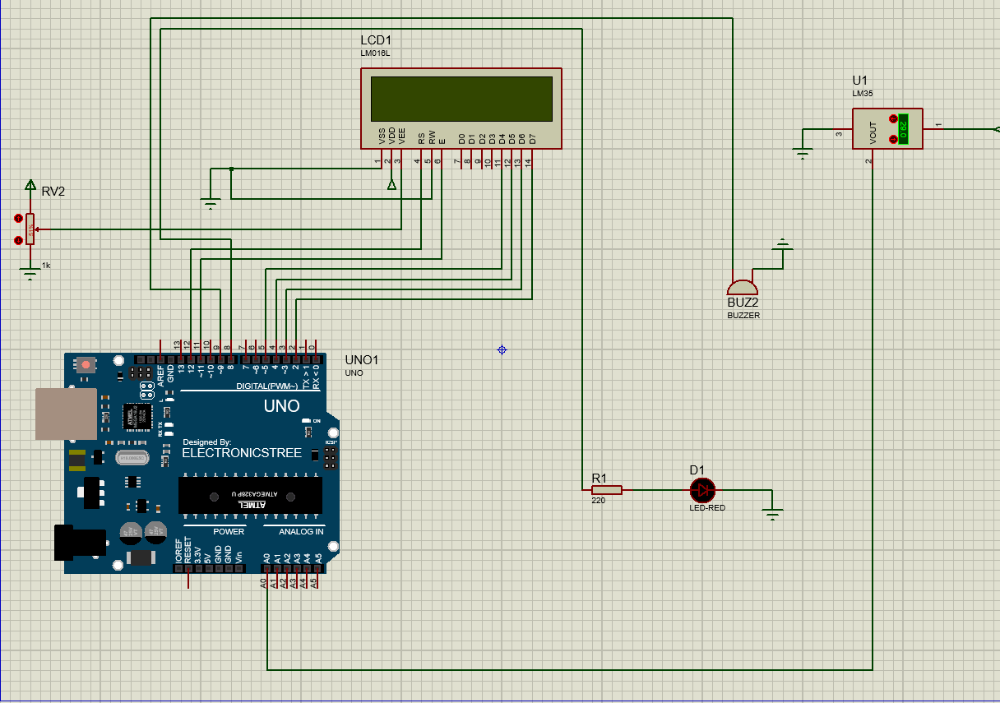
Figure 3 Automatic System Circuit

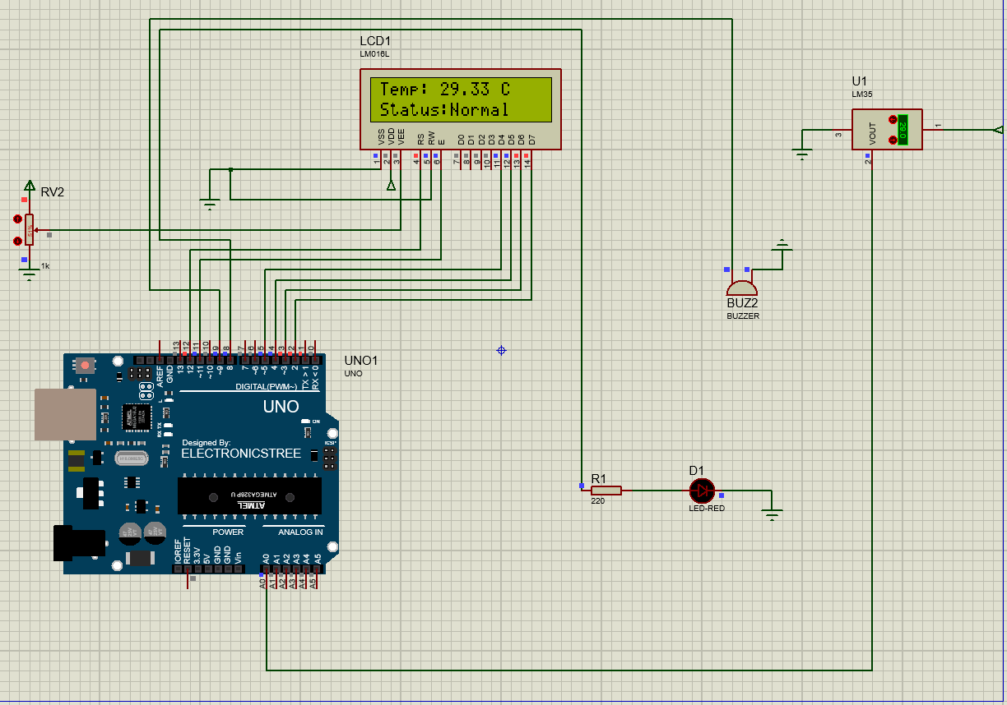
Figure 4 Normal State
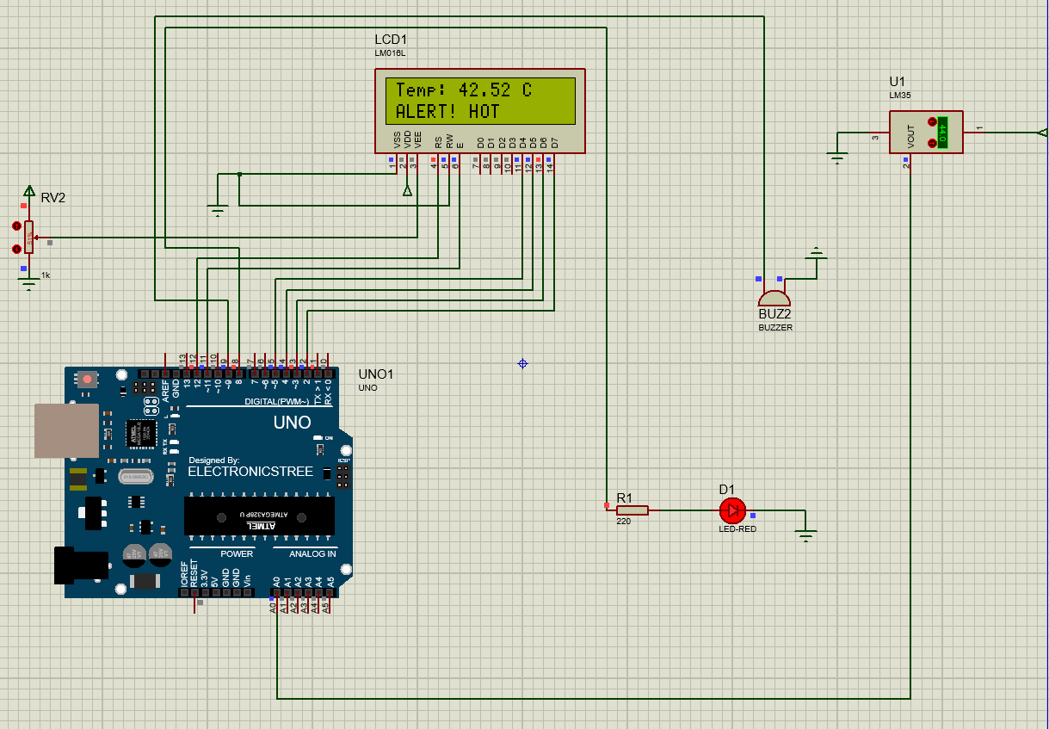
Figure 5 Alert State Triggered

Conclusion:
This project successfully demonstrated IoT-based temperature monitoring and automation using Arduino UNO, LM35 sensor, LCD display, LED, and buzzer in Proteus simulation.

